Multiple-choice section – choose the correct answer

Question 1 [1.1]

The solution to the equation 12 –  = -4 is:

A 5 B -6 C 6 D 12

Question 2 [1.1]

The solution to the equation 7(a – 2) = 2(a – 2) is:

A 4 B 8 C 6 D -2

Question 3 [1.2]

The gradient of the equation 8x – 4y = 12 is:

A 2 B 8 C -2 D 

Question 4 [1.2]

The gradient of the line with equation y = -4 is:

A undefined B 0 C 1 D -4

Question 5 [1.3]

The equation of a linear graph with a y-intercept of 4 and a gradient of - is:

A 3x + 5y = 20 B y + 5 = -x C 3y + 15x = -2 D 2x + 3y = 15

Question 6 [1.4]

The line that is parallel to the line with the equation  is:

A x + 2y = -2 B  C  D 

Question 7 [1.4]

The gradient of a line that is perpendicular to the line with equation  is:

A 2 B -2 C  D 

Question 8 [1.5]

The solution to the inequality  is:

A x = 7 B x < 7 C x ≤ 7 D x > 7

Question 9 [1.5]

Which of the following is not a solution of  < 2?

A x = 1.2 B x =-2.7 C x = 0 D x = -1.8

Question 10 [1.6]

The simultaneous equations y = -3x + 5 and 3y + 2x = -6 have the solution:

A x = -6, y = -4 B x = 3, y = -4 C x = 2, y = 6 D x = 6, y = -2

Multiple-choice results: ___ / 10

Short answer section

Question 11 11 marks

Use words from the list below to complete the following sentences.

linear relationship y = mx + b perpendicular linear equation inequality one inverse operations gradient parallel rise over run y-intercept

(a) The general equation of a straight line is _____________________ where m is the gradient of the line  
and b is the ________________________ of the line.

(b) A ________________________________________ exists between two variables when the graph of the relationship is a straight line.

(c) A linear relationship is described by a ______________________________ .

(d) Linear equations can be solved by applying _______________________________________ to both sides of the equation.

(e) The ______________________of a line is a measure of its steepness, which can be evaluated by evaluating the fraction ______________________________.

(f) Lines that are ___________________ have the same gradients.

(g) Lines that are _______________________________ meet each other at an angle of 90°.

(h) A linear equation has _____ solution and a linear _______________________ has a range of solutions according to the inequality.

Question 12 4 marks [1.3, 1.4]

The line with equation  is shown on the graph. State an equation of a line that is (a) parallel to and  
(b) perpendicular to the line . Sketch each line on the graph below.

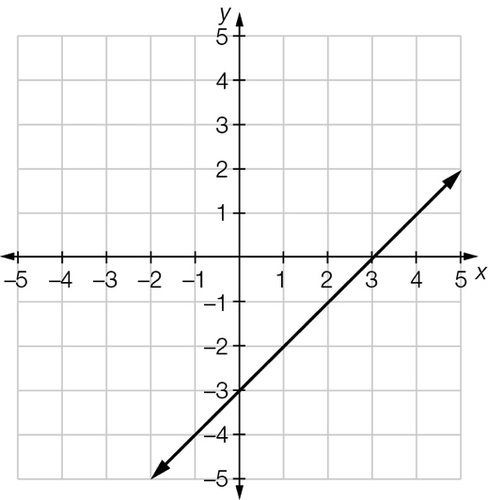

Question 13 3 marks [1.1]

Solve the following equation.



Question 14 4 marks [1.1]

Solve the following equation.



Question 15 2 marks [1.2]

Find the gradient of the line joining the points (2, 6) and (5, 21).

Question 16 2 marks [1.3]

Sketch the graph of y = 4x – 3.

Question 17 4 marks [1.4]

(a) Show that the line with equation  is parallel to the line with equation y = .

(b) Show that the line with equation  is perpendicular to the line with equation .

Question 18 4 marks [1.5]

Solve the following inequalities.

**(a)** 4x – 3 ≤ 17 (b) 6x – 2 > 10

Question 19 4 marks [1.6]

Solve this pair of simultaneous equations.

x = 2y + 4

2y – 4x = 2

Question 20 4 marks [1.6]

Solve this pair of simultaneous equations.

3x – 4y = 13

5x + 3y = 12

Question 21 3 marks [1.1]

A triangle has the dimensions shown. If the perimeter is 24 cm, calculate the lengths of the sides of the triangle. What is wrong with this triangle?

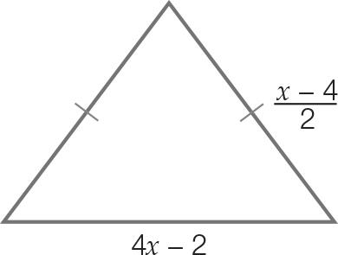

Short answer total:_________/45

Extended answer section

Question 22 6 marks [1.2, 1.3, 1.4]

An elevator is descending towards the basement of a building at a steady rate. It descends 5 m  
every 4 seconds and it reaches the basement (h = 0) after 32 seconds.

(a) Sketch a graph that describes the relationship between the height, h, of the elevator and the time, t.

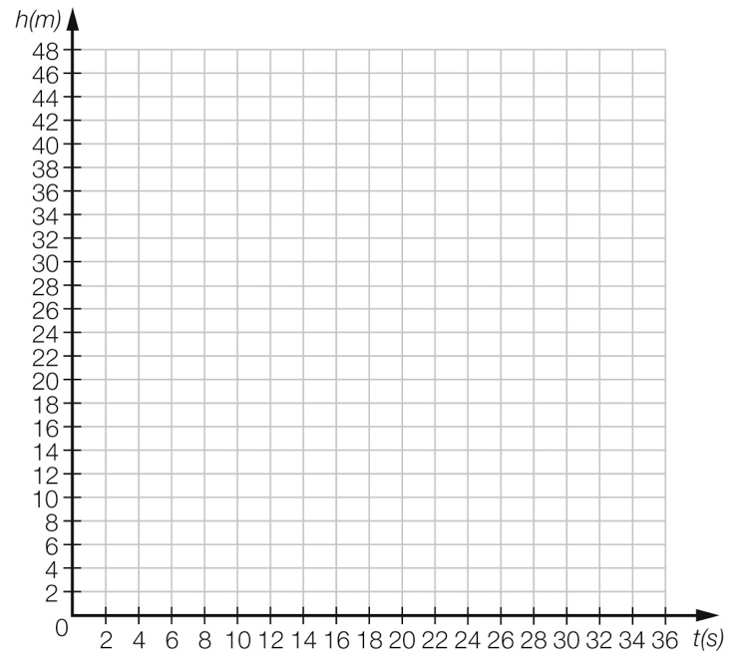

(b) Find the gradient of the graph and hence, the rate of descent of the elevator.

(c) Write an equation that describes the relationship between the height h of the elevator at time t.

(d) How high is the elevator in the building when t = 0?

Question 23 10 marks [1.2, 1.3, 1.4]

(a) Sketch the line with equation  on the set of axes below.

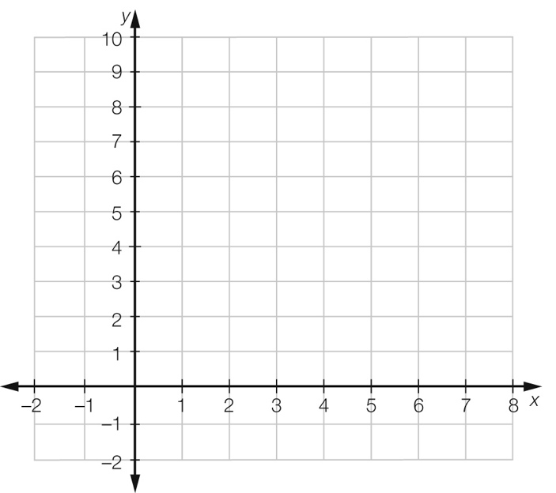

(b) (i) Draw the line AB that passes through the points  and  and find the equation of  
the line AB.

(ii) Prove that the line with equation  is parallel to the line AB.

(c) (i) Draw the line CD that passes through the points  and  and find the equation of  
the line CD.

(ii) Prove that the line with equation  is perpendicular to the line CD.

Question 24 4 marks [1.6]

A baker uses dried fruit in the fruit buns she makes. She has already used one-third the contents of the  
last 6 kg bag she has and wants to know how many more buns could possibly be made before she  
gets the new supply. Each bun uses 10 g of dried fruit ingredients.

(a) Write an inequality that describes the baker’s situation.

(b) Solve the inequality to find out how many buns could be made.

Question 25 5 marks [1.5]

Rocky bought 4 apples and 2 bananas for $1.00. Dran bought 2 apples and 6 bananas for $1.50.  
How much did each piece of fruit cost?

Extended answer total:______/25

TOTAL test results: ______ / 80